

**Student Assessment Record**

Group Report

Section No : B-10

Group No :

Group Leader : Y.Bharath Kumar

Members of the Team : 5

|  |  |  |  |
| --- | --- | --- | --- |
| **S.No** | **Name of the Student** | **Register Number** | **Signature of the Student** |
| 1 | Y.Bharath kumar | 9922005075 |  |
| 2 | M.Divakar reddy | 99220041736 |  |
| 3 | H.Dheeraj kishore | 99220040269 |  |
| 4 | T.Akash Reddy | 99220040209 |  |
| 5 | K.Maharshi | 9922008383 |  |

Title of the Project : MINI ELECTION SYSTEM

Signature of the Examiner with Date

Department of Computer Science Engineering School of Freshman Engineering

Kalasalingam Academy of Research and Education

1. INTRODUCTION

Candidate registration, document verification, and auto-generated User ID and pass for candidates and voters will all be part of the online election system. Election Commission will be in charge of the Admin Login. Candidate Login will be taken care of. Voters will be given a unique ID and password by each candidate, which they will use to vote for that candidate just once every election. The initiative benefits the Election Commission, voters (who may learn about the candidate's past and make informed decisions), and candidates.

The software system enables candidates to access their profiles and submit all of their information, including prior milestones. The administrator may review each Candidate's information and papers; only after that, the Candidate's ID and Password will be produced, and incorrect accounts can be removed. Voters may access a list of Candidates in their region via the software system. The administrator has full control over the system and may regulate and remove any information that isn't related to the election rules

Voter can use his her voting right offline without any difficulty. He/ She has to be registered first for him/her to vote. Registration is mainly done by the system administrator for security reasons. The system Administrator registers the voters on a special site of the system visited by him only by simply filling a registration form to register voter. Citizens seeking registration are expected to contact the system administrator to submit their details. After the validity of them being citizens of of that particular group/college has been confirmed by the system administrator by comparing their details submitted with those in existing databases.

1. OBJECTIVE OF THE PROJECT

Traditional voting system

In efficient

Takes time and human resources. ➢

Does not give an instant Poll result. ➢

Hard to track who voted and who don’t

**Offline Mini Election system** ➢

Instant Poll result ➢

Easy to keep track of voters

Reviewing the existing/current voting process

Coming up with an automated voting system

Implementing an offline voting system

Validating the system to ensure that only eligible voters are allowed to vote

Keeps the record of the every voting process

Allows us to setup a flexible and trustworthy voting system

Applicable for large and as well as small group of people

Reduce the time spending in long queues

Vote miscount can be solved

1. DESIGN OF THE SYSTEM

**START**

INPUT: votescount1=0

votescount2=0

Votescount3=0

Votescount4=0

Spoiledvotes=0

spoo

Do while loop

Case 1

cast the vote

Id checking

Case 2

Yes No

Admin panel

Id check

Print not eligible

Print voting form

Yes No

Record ballot votescount++

Case 1

Wrong id or password

Vote count

Leading candidate

Case 2

End

1. SYSTEM SPECIFICATION/ FUNCTION MODULES
2. CAST THE VOTE :

You are asked to enter your student id to verify your profile and it will check in the database and confirms your eligibility.It allows you to see the list of candidates participating in the elections.Then, you can cast your vote to your favourable candidate he/she who you are willing to be the leader. It is your choice to cast to your favourite candidate.

1. ADMIN PANEL :

It is a secure panel only admin will have access into this panel. After choosing this option you are asked to enter the admin user id and password.It will verify the id and password and shows the options belonging to admin panel. After entering into the admin panel it will shows you two options to select you can select either one or two. Now the first option is the vote count and the second option is the leading candidate.

1. Vote count :

Here the admin can able to see the vote count of each candidate that is the number of votes gained by each candidate in the election.

1. Leading candidate:

Here the admin can see the candidate with leading number of votes gained in the election and he could be the winner of the election with majority of votes gained from voters.

1. IMPLEMENTATION

#include<stdio.h>

#include<conio.h>

#define CANDIDATE_COUNT

#define CANDIDATE1 "TONY STARK [🛩️]"

#define CANDIDATE2 "STEVE ROGERS [🚁]"

#define CANDIDATE3 "BRUCE BANNER[🚙]"

#define CANDIDATE4 "NATASHA ROMANOFF[🏍️]"

int votesCount1=0, votesCount2=0, votesCount3=0, votesCount4=0, spoiledvotes=0;

Int a[100]={1101,1102,1103,1104,1105,1106,1107,1108,1109,1110,1111,1112,1113,1114,1115,1116,1117,1118,1119,1120};

void castVote() {

clrscr();

int choice,studentid,count=0,pos=21,i;

printf("\n Enter your Student ID : ");

scanf("%d",&studentid);

for(i=0;i<=100;i++)

{

if(a[i]==studentid)

{

count++;

}

}

for(i=100;i>=pos-1;i--)

{

a[i+1]=a[i];

a[pos-1]=studentid;

}

pos++;

if(count==1)

{

printf("\n\n ### Please choose your Candidate ####\n\n");

printf("\n 1. %s", CANDIDATE1);

printf("\n 2. %s", CANDIDATE2);

printf("\n 3. %s", CANDIDATE3);

printf("\n 4. %s", CANDIDATE4);

printf("\n 5. %s", "None of These");

printf("\n\n Input your choice (1 - 4) : ");

scanf("%d",&choice);

switch(choice) {

case 1:

votesCount1++;

break;

case 2:

votesCount2++;

break;

case 3:

votesCount3++;

break;

case 4:

votesCount4++;

break;

case 5:

spoiledvotes++;

break;

default:

printf("\n Error: Wrong Choice !! Please retry");

//hold the screen

getchar();

}

printf("\n thanks for vote !!");

clrscr();

}

else if(count>1)

{

printf("\n You Have Already Casted Your Vote\nCheck your Id");

}

else

{

printf("\n Error: Wrong Student Id");

}

}

void votesCount() {

clrscr();

printf("\n\n ##### Voting Statics ####");

printf("\n %s - %d ", CANDIDATE1, votesCount1);

printf("\n %s - %d ", CANDIDATE2, votesCount2);

printf("\n %s - %d ", CANDIDATE3, votesCount3);

printf("\n %s - %d ", CANDIDATE4, votesCount4);

printf("\n %s - %d\n ", "Spoiled Votes", spoiledvotes);

}

void getLeadingCandidate() {

clrscr();

printf("\n\n #### Leading Candidate ####\n\n");

if(votesCount1>votesCount2 && votesCount1>votesCount3 && votesCount1 >votesCount4)

printf("[%s]",CANDIDATE1);

else if (votesCount2>votesCount3 && votesCount2>votesCount4 && votesCount2 >votesCount1)

printf("[%s]",CANDIDATE2);

else if(votesCount3>votesCount4 && votesCount3>votesCount2 && votesCount3 >votesCount1)

printf("[%s]",CANDIDATE3);

else if(votesCount4>votesCount1 && votesCount4>votesCount2 && votesCount4 >votesCount3)

printf("[%s]",CANDIDATE4);

else

printf("----- Warning !!! No-win situation----");

}

void admin() {

int admin,adminid,password,n;

clrscr();

printf("\n\n #### Admin Panel ####");

while(admin!=0)

{

printf("\n Enter your user Id : ");

scanf("\n%d",&adminid);

printf("\n Enter password : ");

scanf("\n%d",&password);

if(adminid==992200&&password==2004)

{

printf("\n 1. Find Vote Count");

printf("\n 2. Find leading Candidate");

printf("\n 0. Exit");

printf("\n\n Please enter your choice : ");

scanf("%d",&n);

switch (n)

{

case 1:

votesCount();

break;

case 2:

getLeadingCandidate();

break;

case 0:

clrscr();

break;

default :

printf("\nError: Invalid Choice");

}

admin=0;

}

else

{

printf("\nError: Enter correct Id and password");

}

}

}

void main(){

int choice;

clrscr();

do {

printf("\n\n ###### Welcome to Election/Voting 2022 #####");

printf("\n\n 1. Cast the Vote");

printf("\n 2. Admin Panel");

printf("\n\n Please enter your choice : ");

scanf("%d", &choice);

switch(choice)

{

case 1:

castVote();

break;

case 2:

admin();

break;

default:

printf("\nError: Invalid Choice");

}

}

while(choice!=0);

//hold the screen

getchar();

}

1. IMPLEMENTATION SCREENSHOTS

**WELCOME PANEL**

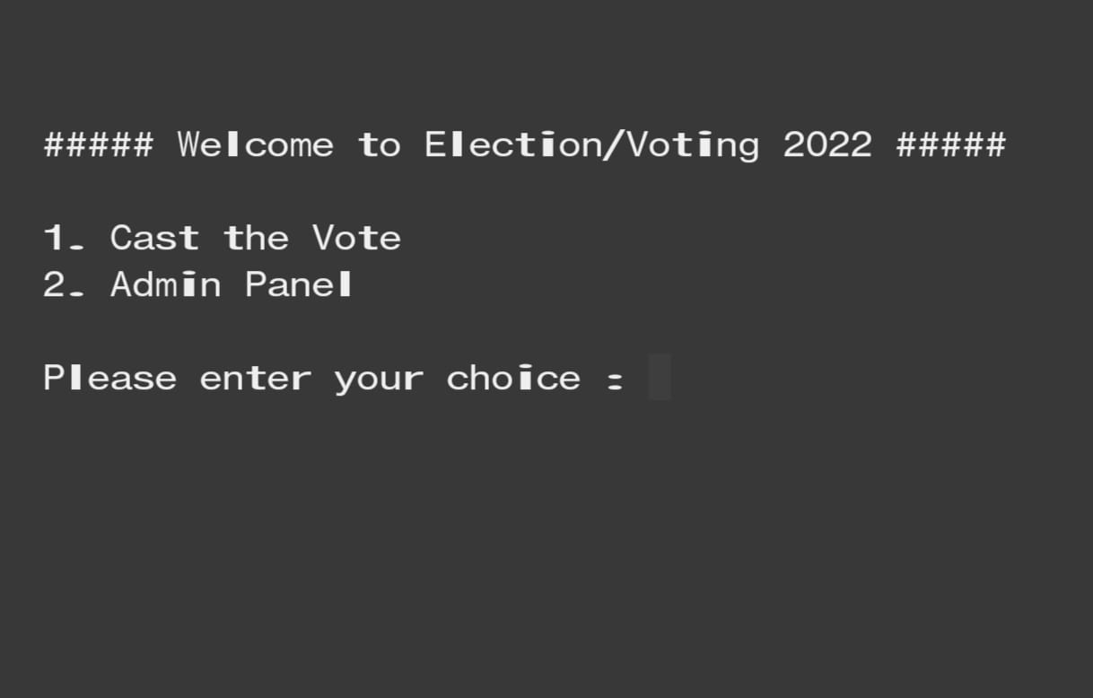

**CHECKING STUDENT ID**

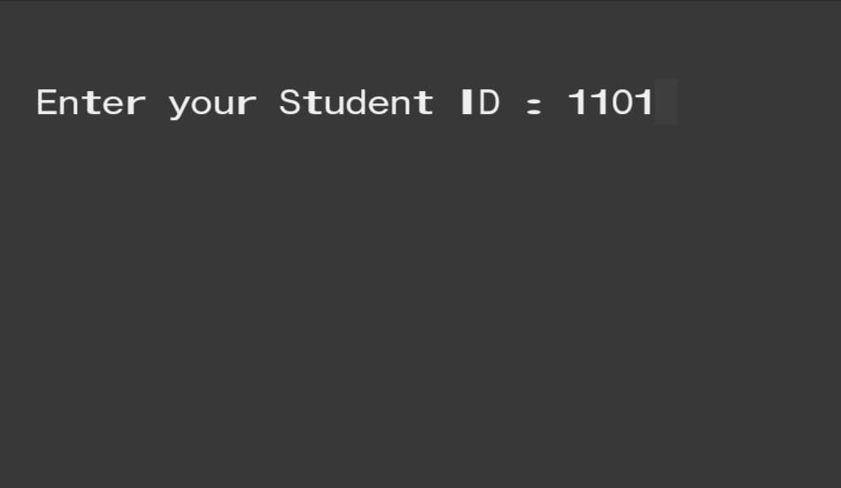

**CAST YOUR VOTE**

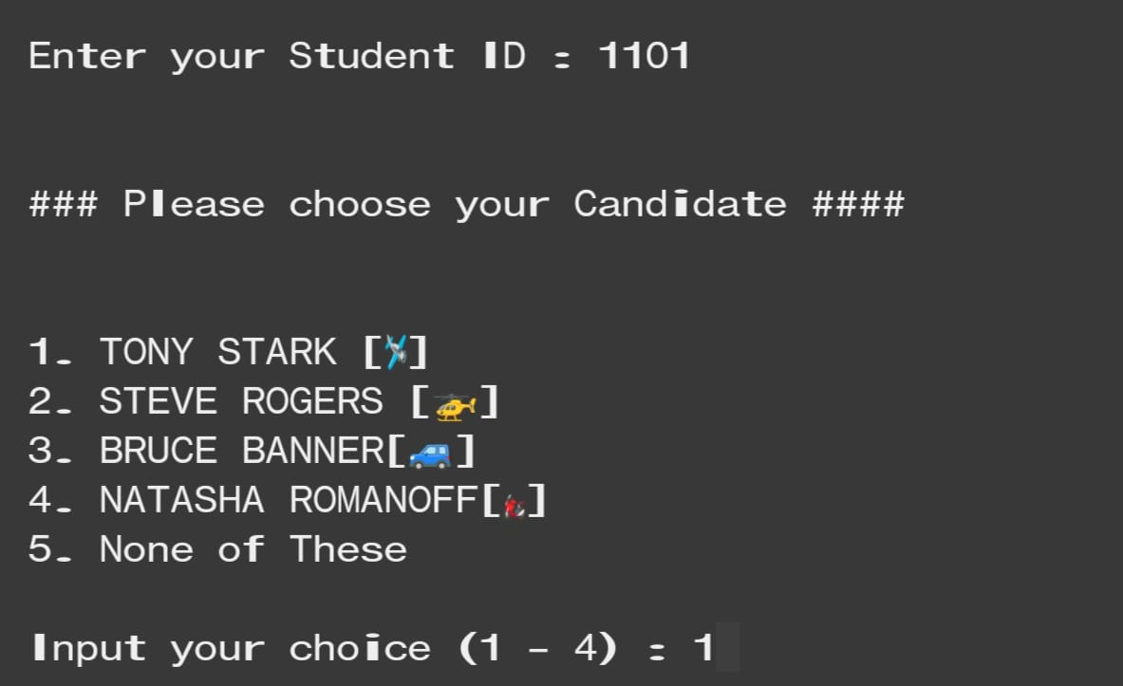

**WRONG STUDENT ID**

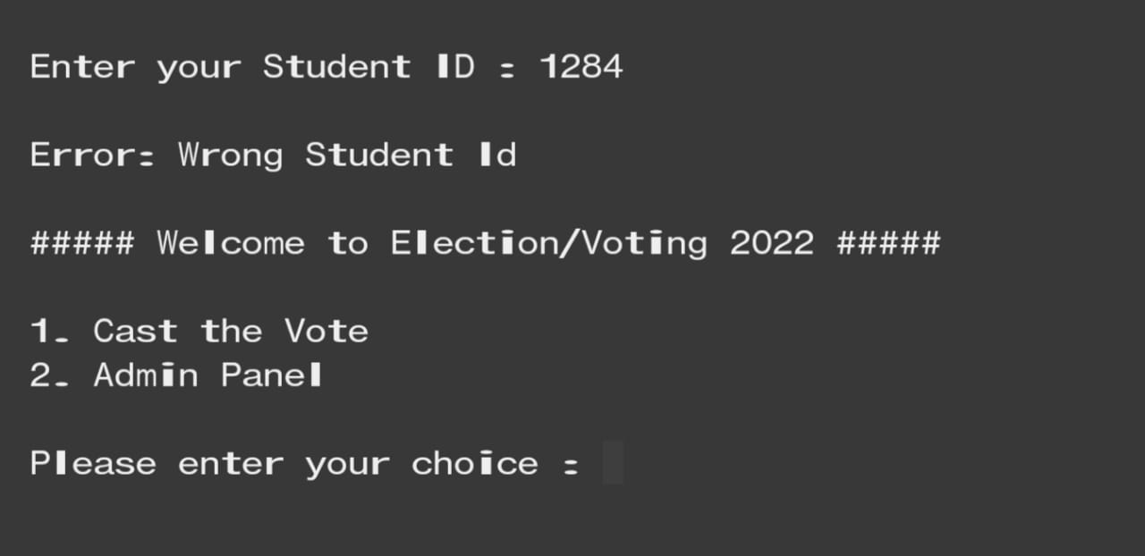

**REPEATED VOTING**

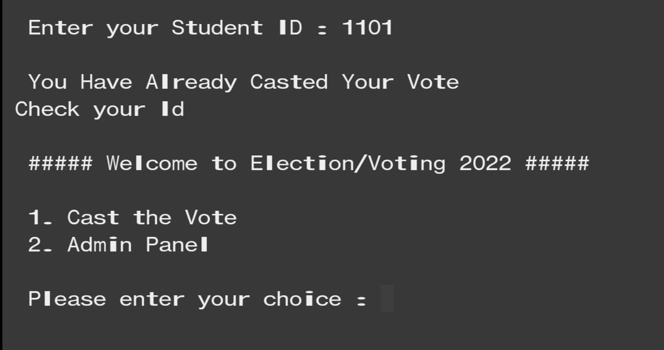

**ADMIN PANEL ID VERIFICATION**

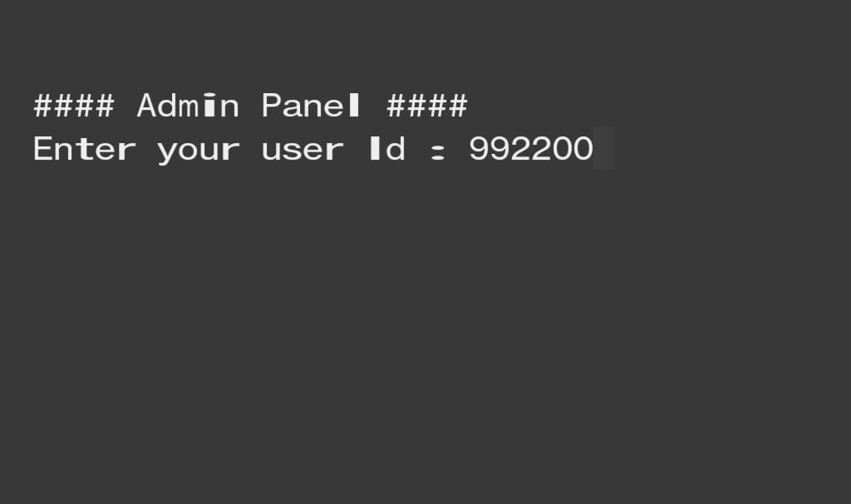

**ADMIN PANEL**

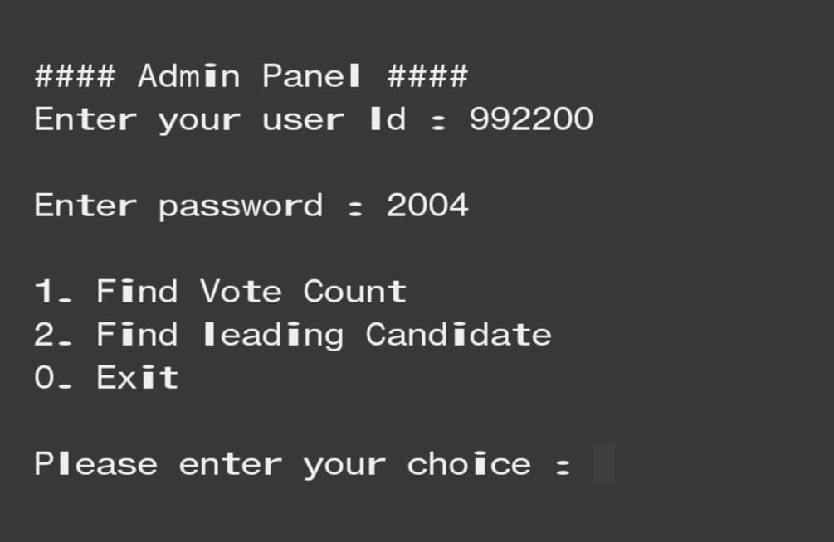

**WRONG ADMIN ID OR PASSWORD**

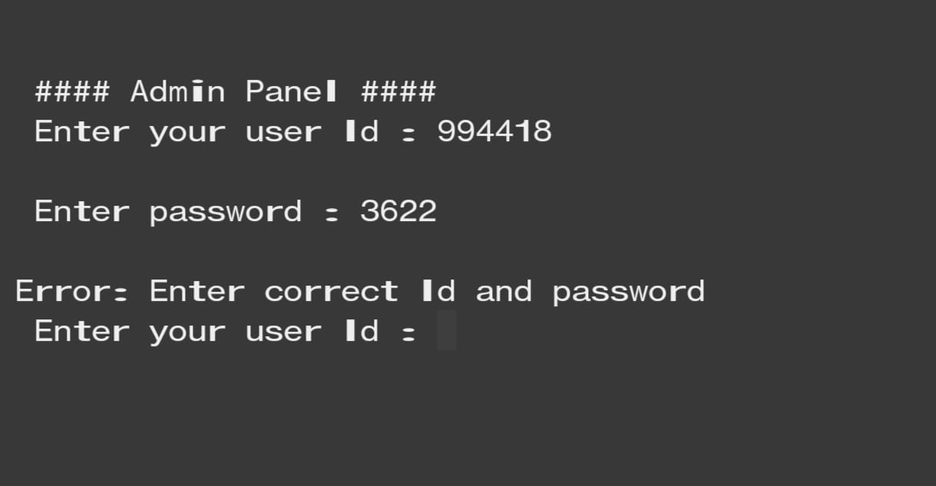

**VOTE COUNT**

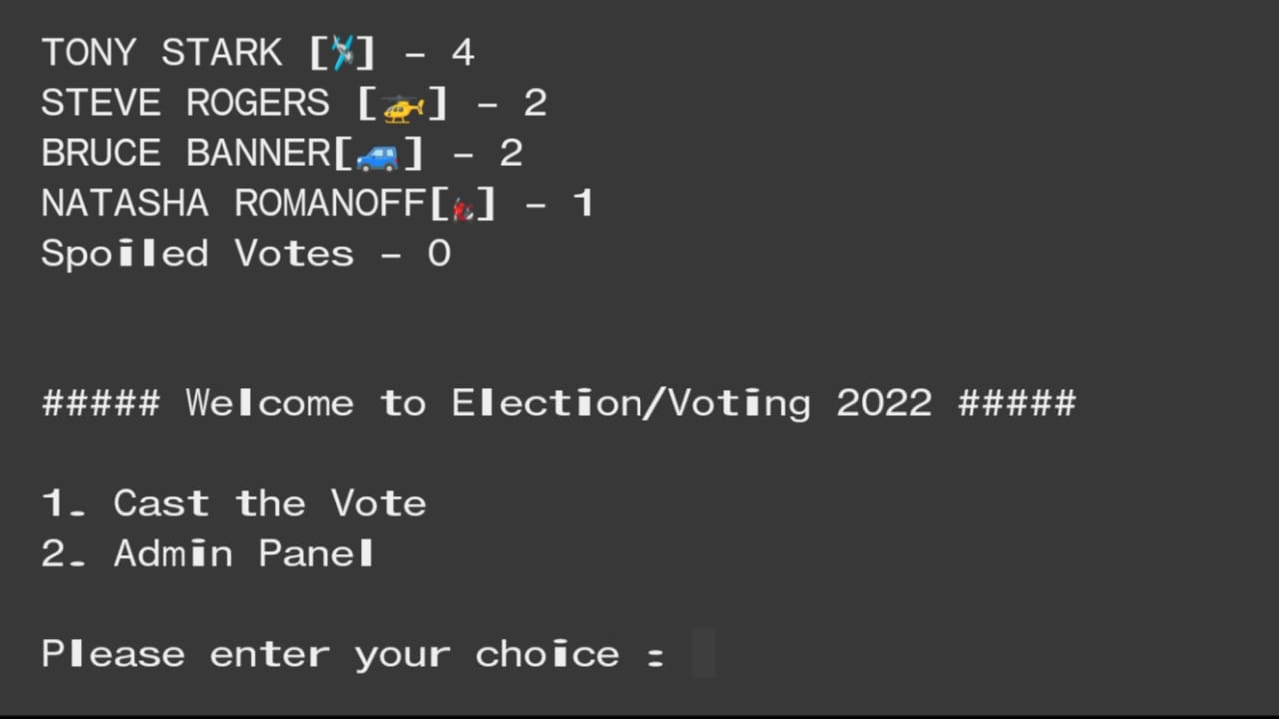

**LEADING CANDIDATE**

